Fg and Bg Commands

The fg command, short for the foreground, is a command that moves a background process on your current Linux shell to the foreground.

This contrasts the bg command, short for background, that sends a process running in the foreground to the background in the current shell.

Jobs: Jobs command is used to list the jobs that you are running in the background and in the foreground. If the prompt is returned with no information no jobs are present. All shells are not capable of running this command.

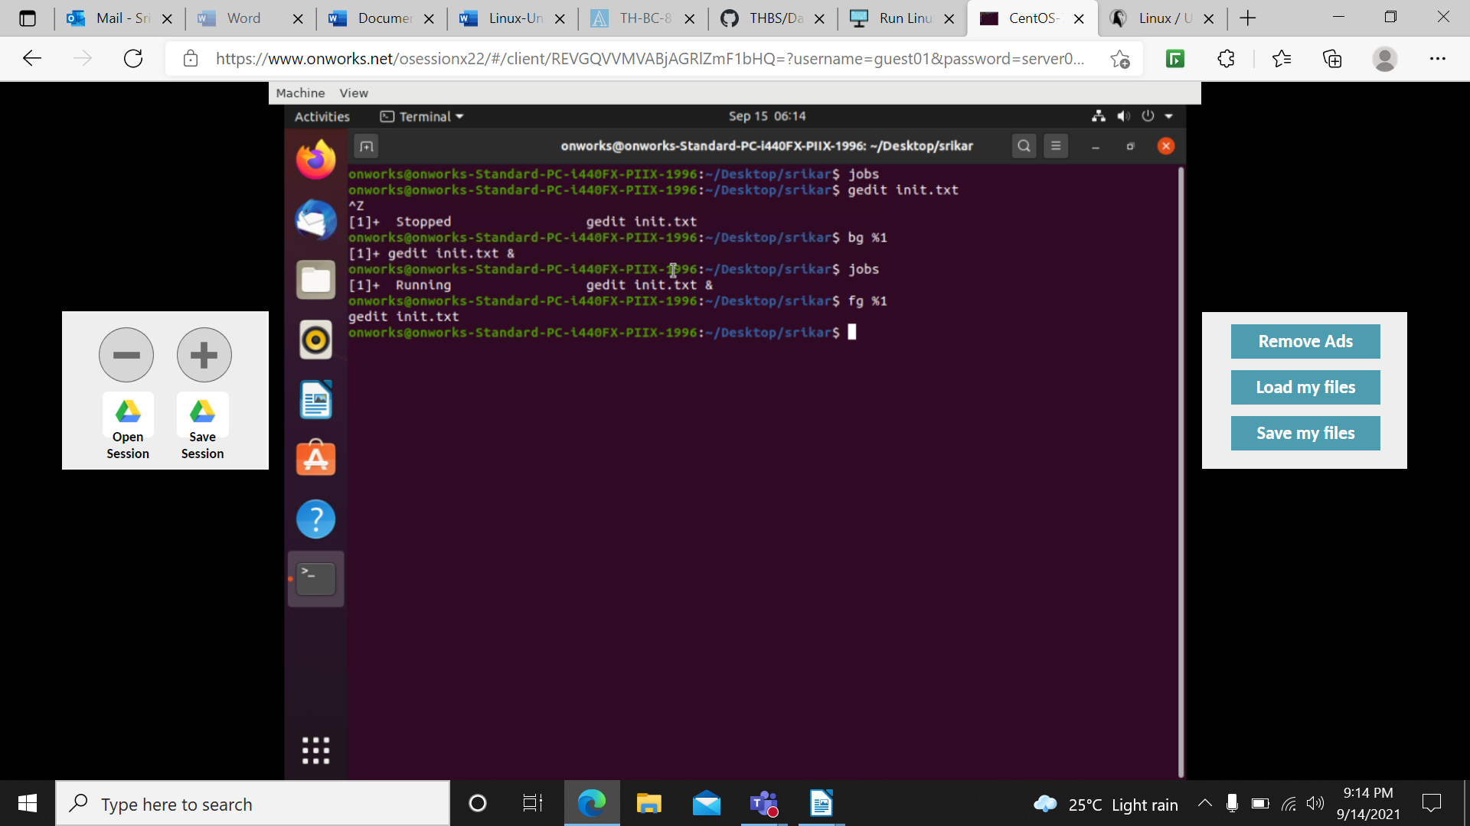

More/less:

more and less have the option to view multiple files at once. more allows us to view them as a single file separated by lines, and less allows us to switch between them. However, both more and less display all the opened files with the same options.

Example: less filename.txt

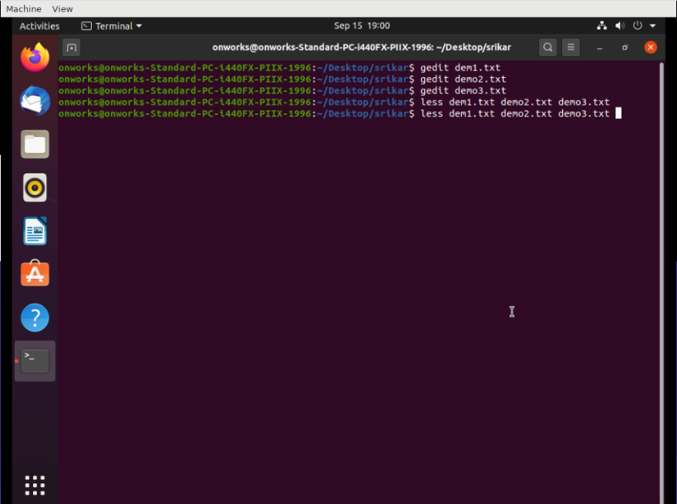

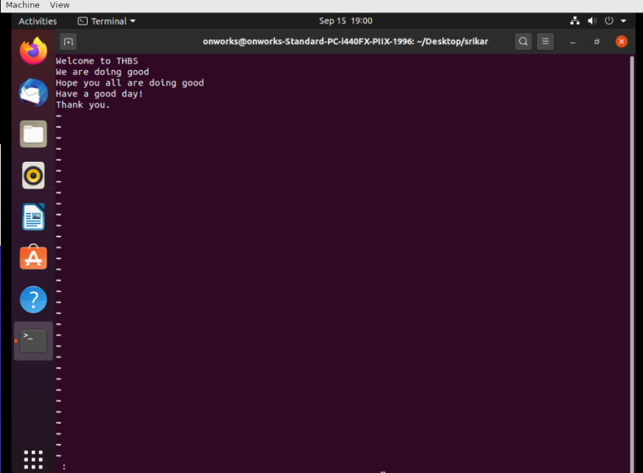

:p -> to move to previous file.

:n -> to move to next file.

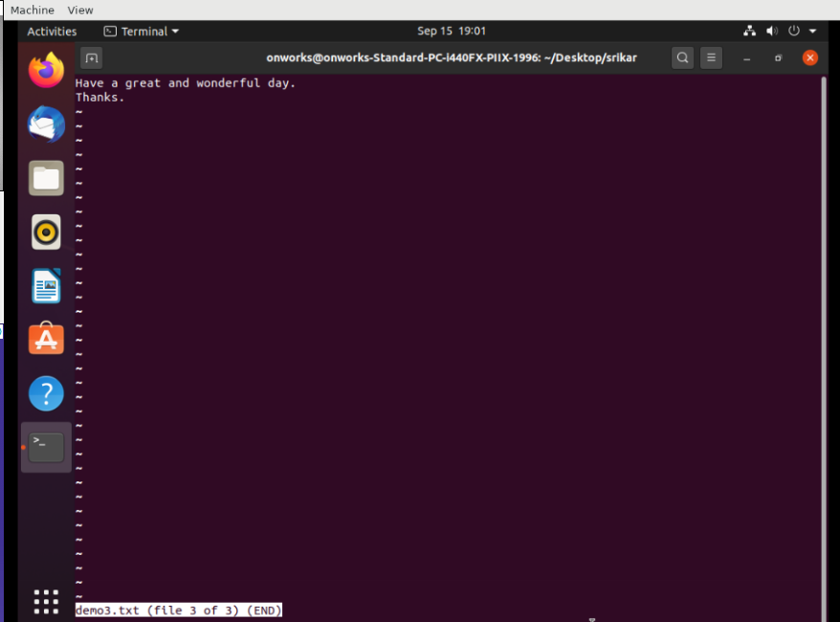

Less -X filename.txt:

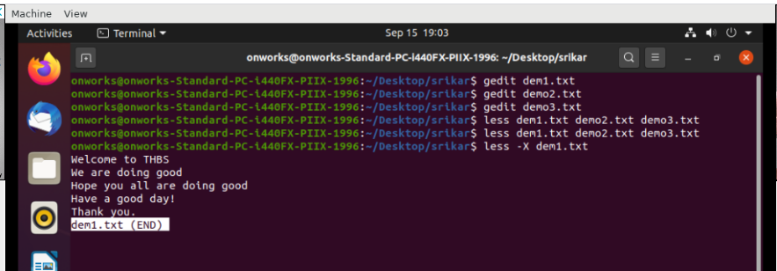

Less -f filename.txt:

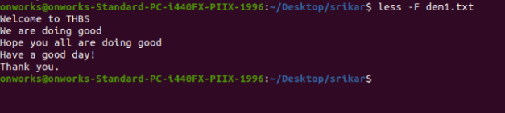

Tail:

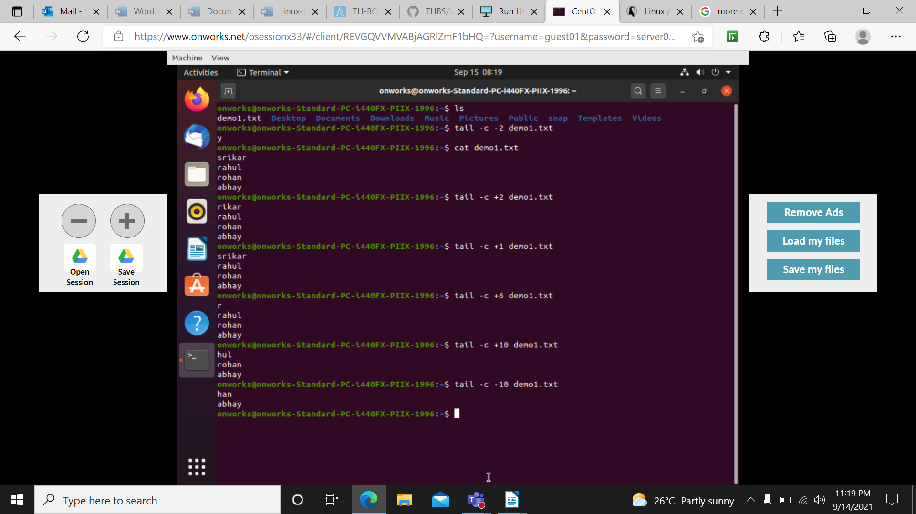 tail -c -6 demo1.txt → it displays from 6th character to last character

head file1 file2 file 3

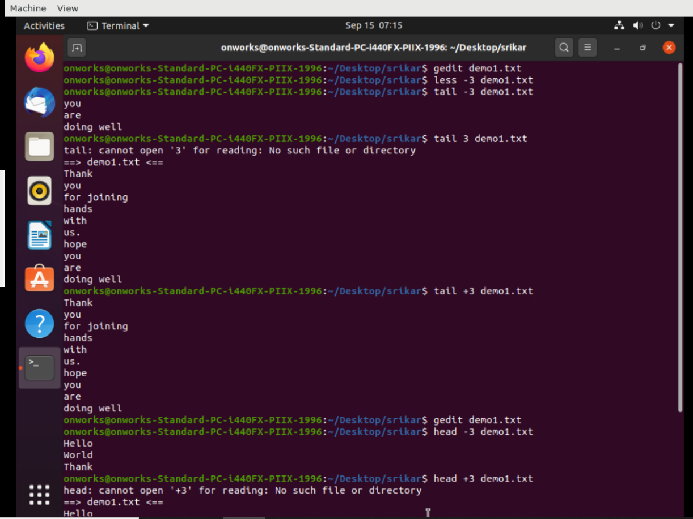

Head +3 demo1.txt, head -3 demo1.txt

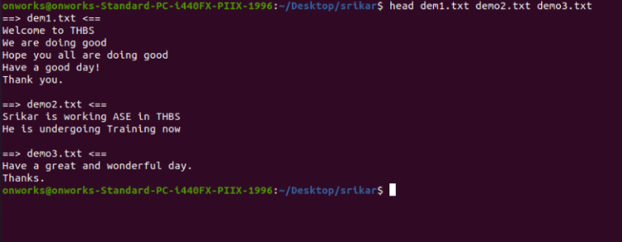

head filename.txt | sort

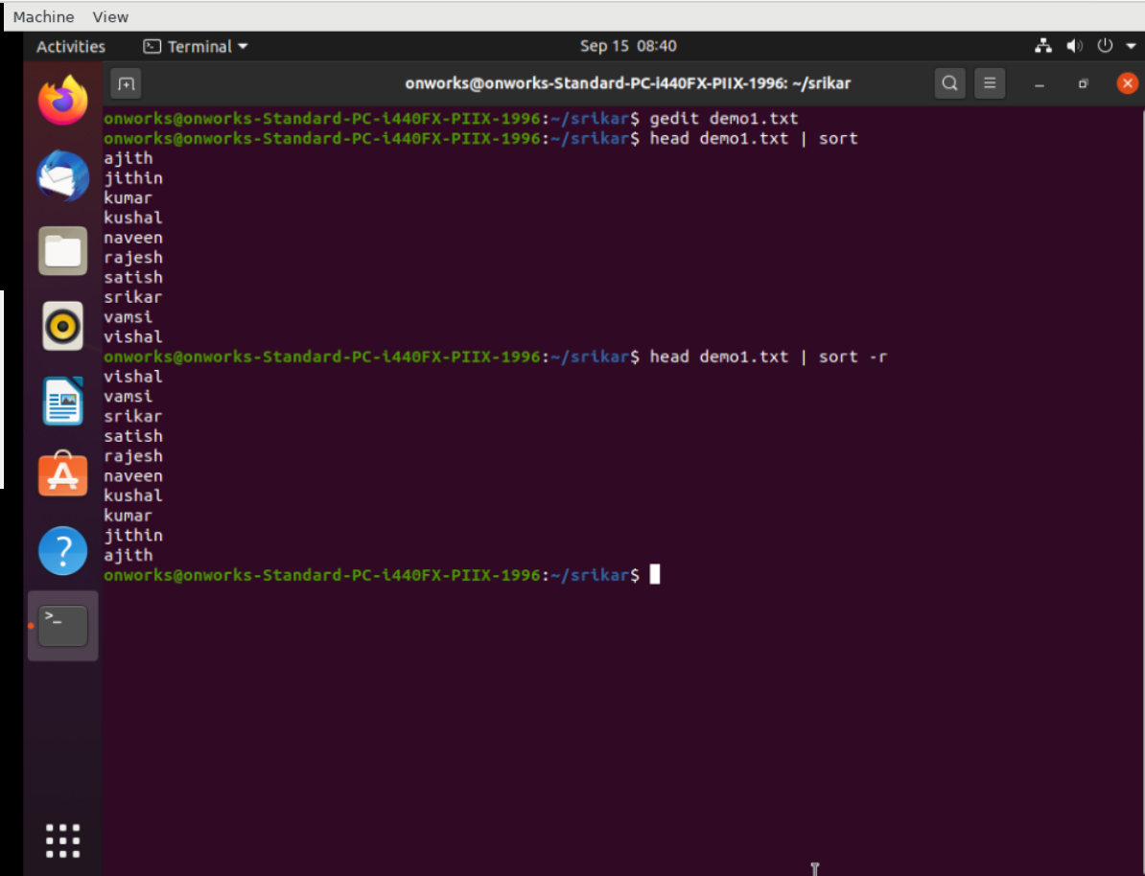

cat commands:

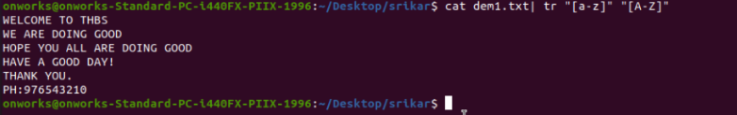

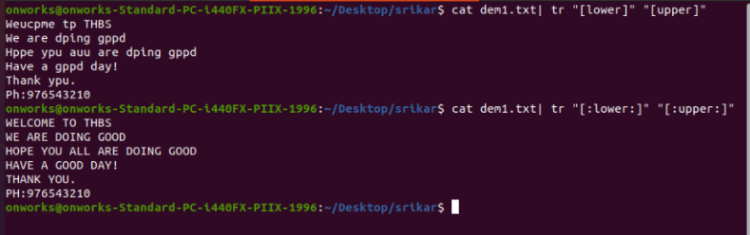

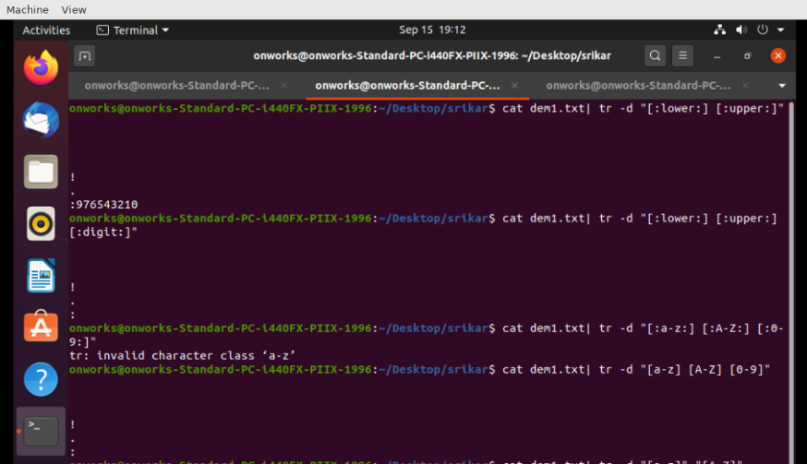

cat demo2.txt | tr -d [:digit:]

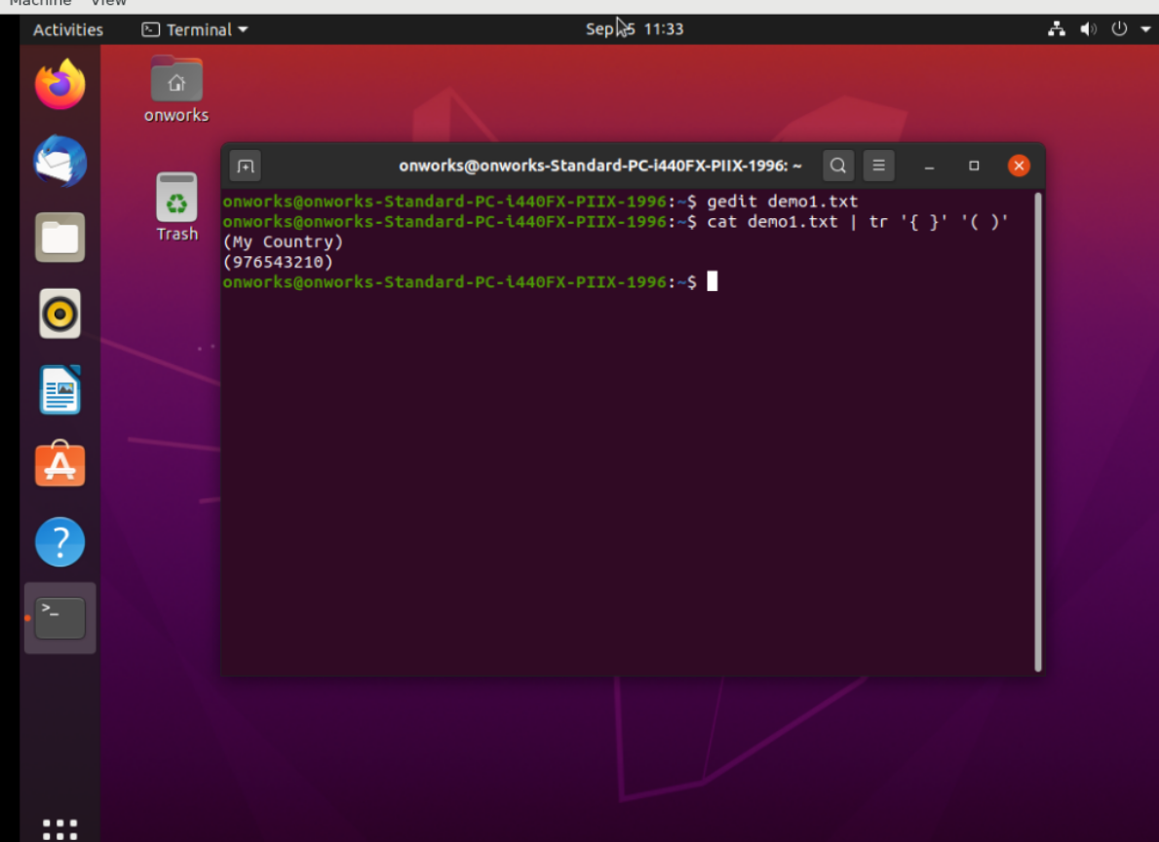

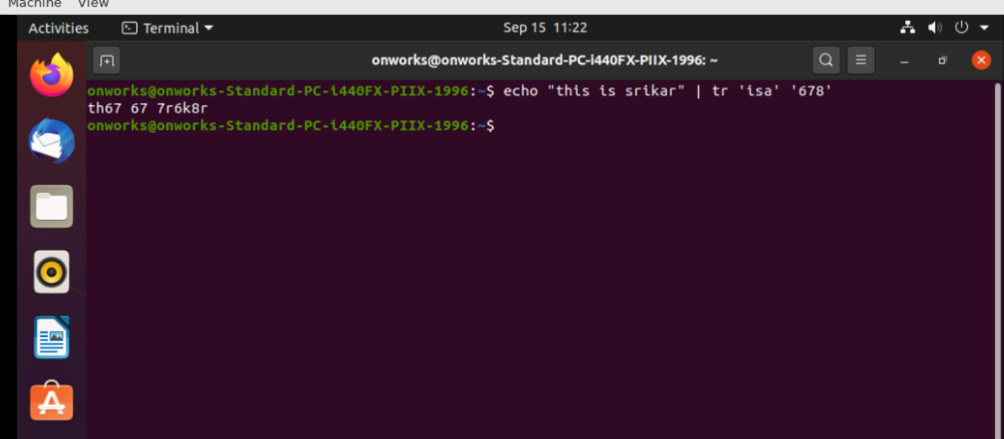

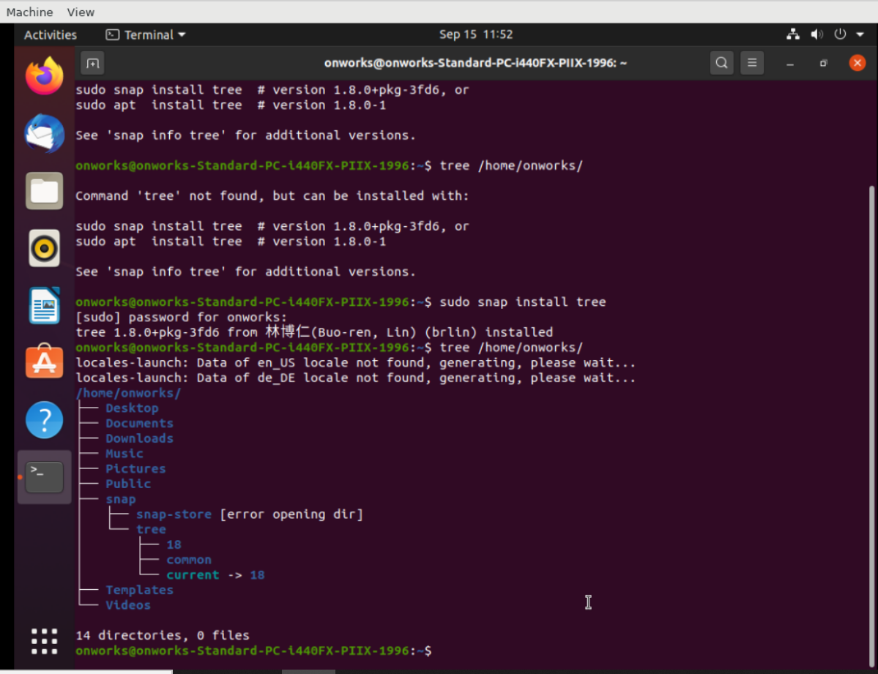 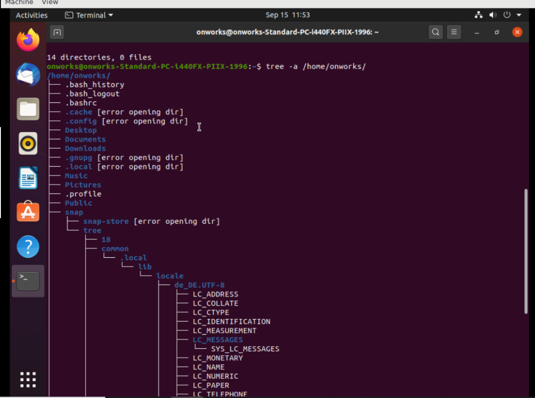tree: tree is a recursive directory listing program that produces a depth-indented listing of files.

Find: The find command in UNIX is a command line utility for walking a file hierarchy. It can be used to find files and directories and perform subsequent operations on them. It supports searching by file, folder, name, creation date, modification date, owner and permissions. By using the ‘-exec’ other UNIX commands can be executed on files or folders found.

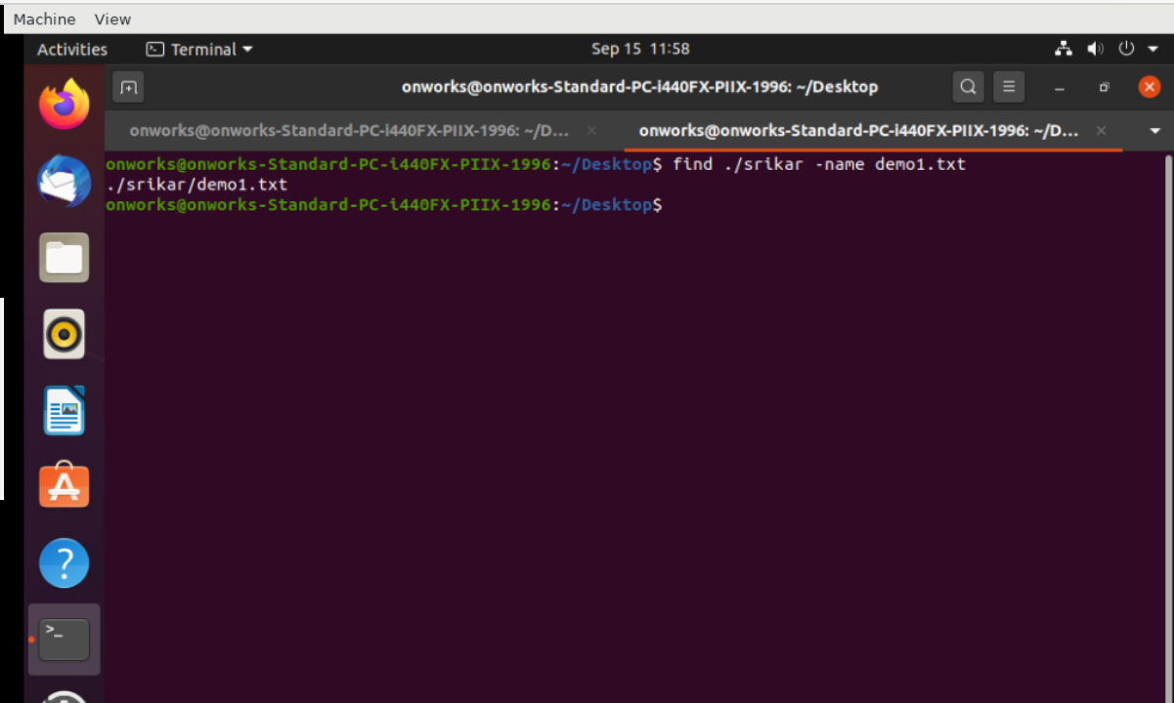

Awk: Awk is a scripting language used for manipulating data and generating reports.

